**EXPERIMENT 01**

**AIM:** TO DESIGN A USER PERSONA OF AN APPLICATION

**EXPLANATION:**

**Personas** are archetypical users whose goals and characteristics represent the needs of a larger group of users. Usually, a persona is presented in a one or two-page document (like the one you can see in the example below). Such 1–2-page descriptions include behaviour patterns, goals, skills, attitudes, and background information, as well as the environment in which a persona operates. Designers usually add a few fictional personal details in a description to make the persona a realistic character (e.g. quotes of real users), as well as context-specific details.

**Why do we use Persona?**

Numerous research data for product design are quite difficult to handle, especially when we need to pay attention to the data throughout the entire process. Therefore, Persona will be a relatively more realistic and concrete object, although not a real person, it is the most typical image of many real Personas. And it can remind us of the users’ needs and help us make a better user experience model because of which real users will feel more comfortable while using product. This is why it can facilitate the development.

**Topic for which persona is created is an Online Cosmetics Platform.**

**The following Persona is created for the owner of the brand.**

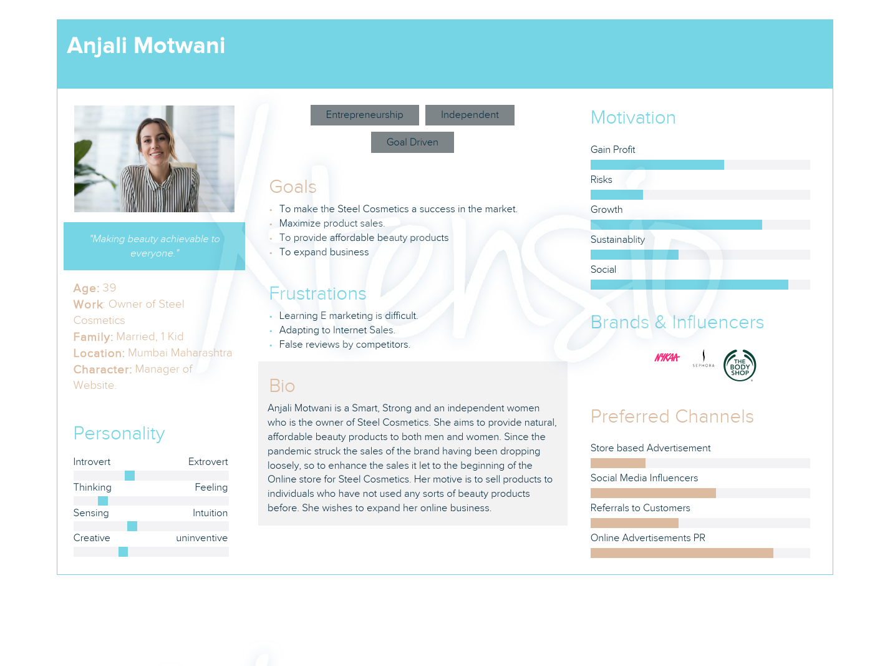

**The following Persona is created for the customer of the steel cosmetic**

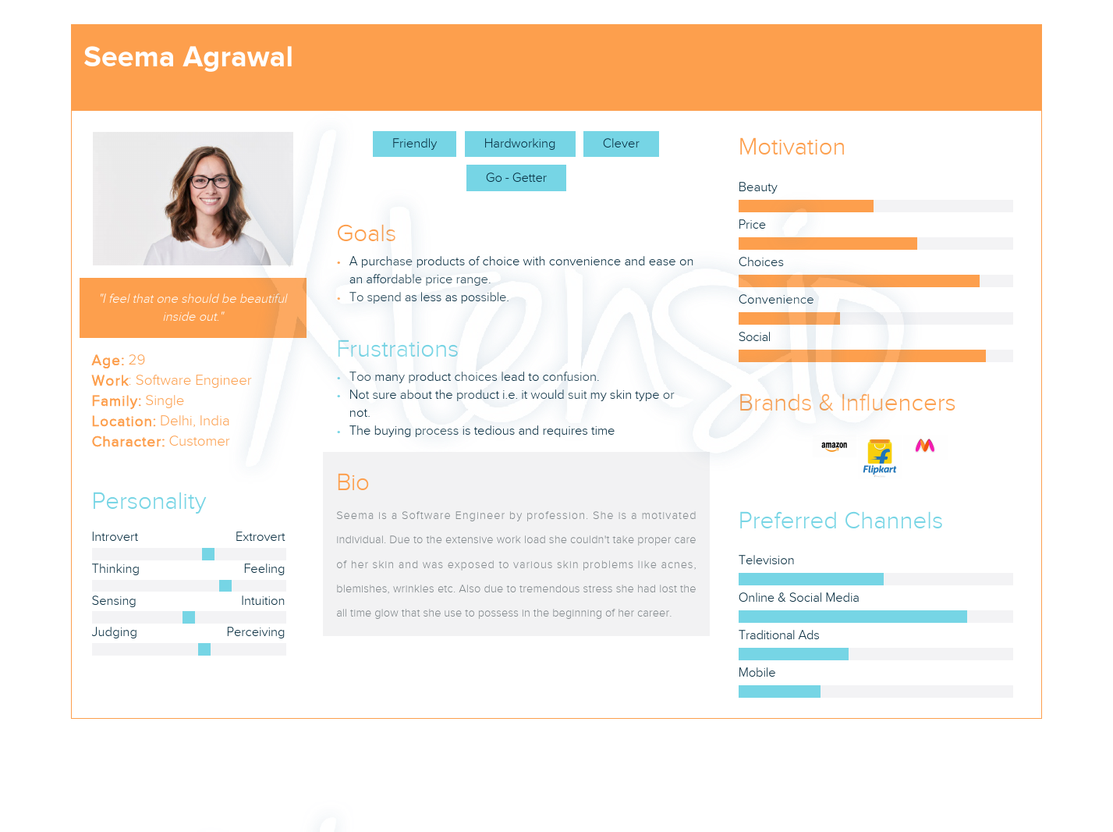

**Persona for a web designer of steel cosmetics**

